Article:

<https://medium.com/%E0%A6%AA%E0%A7%8D%E0%A6%B0%E0%A7%8B%E0%A6%97%E0%A7%8D%E0%A6%B0%E0%A6%BE%E0%A6%AE%E0%A6%BF%E0%A6%82-%E0%A6%AA%E0%A6%BE%E0%A6%A4%E0%A6%BE/%E0%A6%B0%E0%A6%BF%E0%A7%9F%E0%A7%87%E0%A6%95%E0%A7%8D%E0%A6%9F-usecallback-%E0%A6%8F%E0%A6%AC%E0%A6%82-usememo-%E0%A6%B9%E0%A7%81%E0%A6%95-%E0%A6%AA%E0%A6%B0%E0%A7%8D%E0%A6%AC-%E0%A7%A7-48b81885141f>

Code - 1:

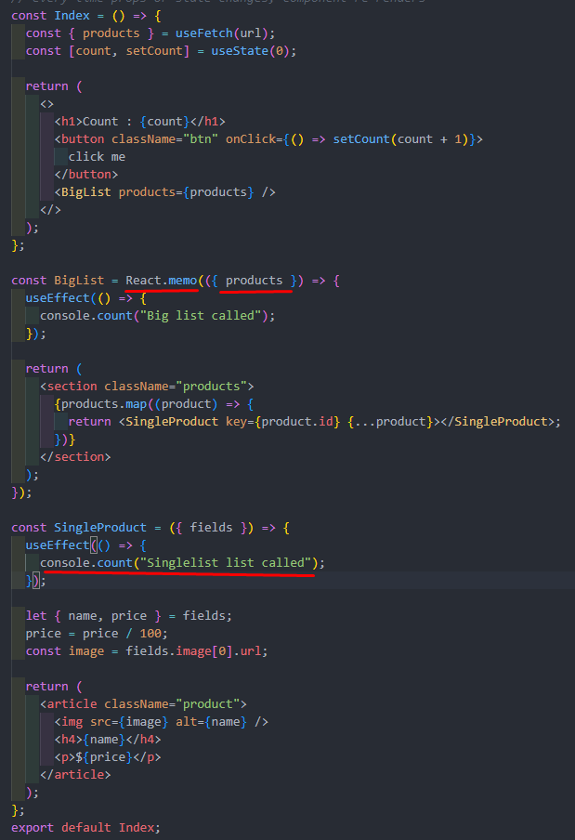

*every time props or state changes, component re-renders*

Ekhane props (products) change hoi ni. So re-render o hobe na.

Code - 2:

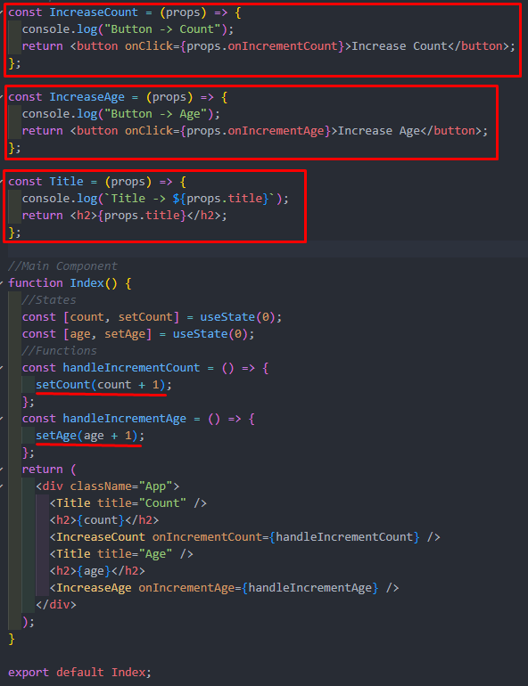

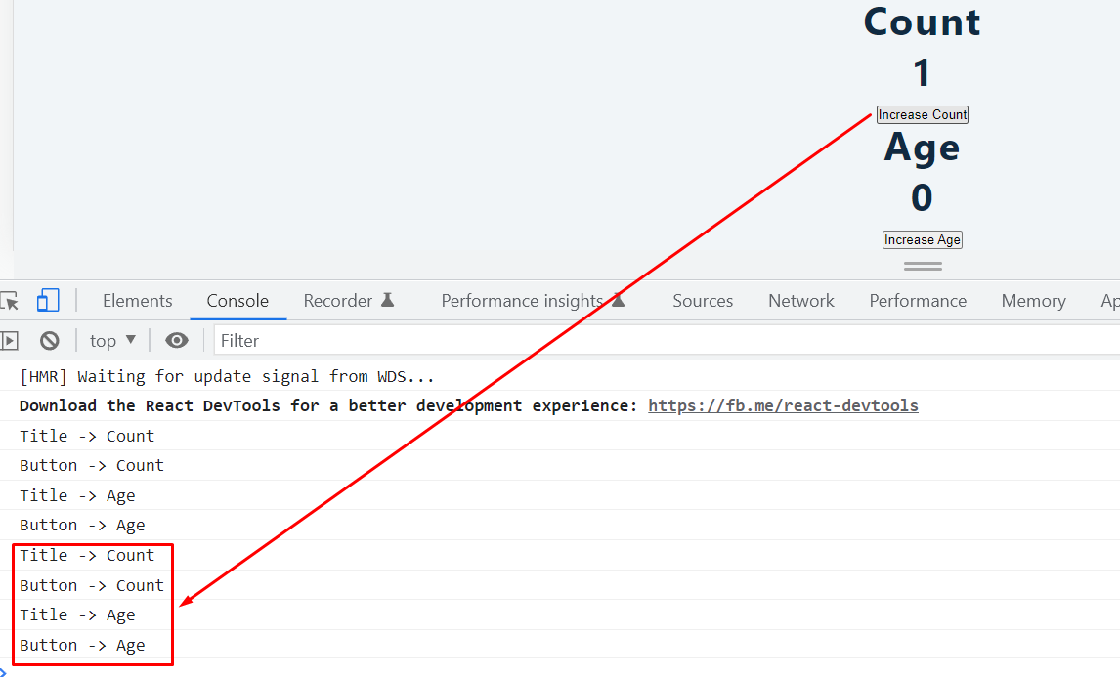

Ekhane shobgulo render holo. So,shob print korlo.

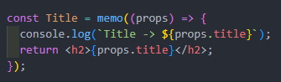

Ekhon amra memo function use korlam. So,render hobe na.

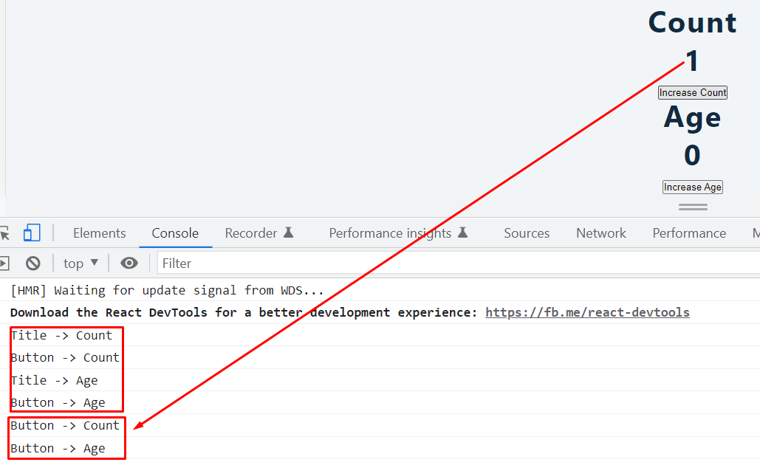

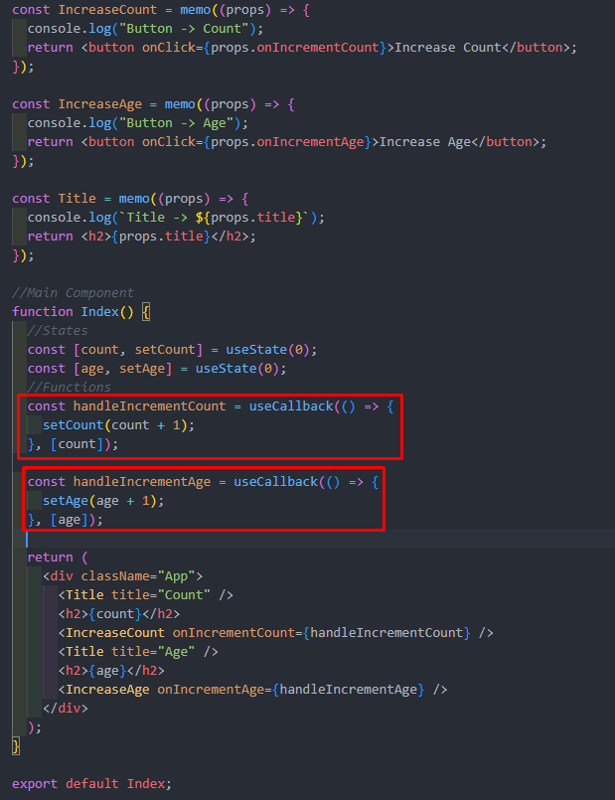

Code - 3:

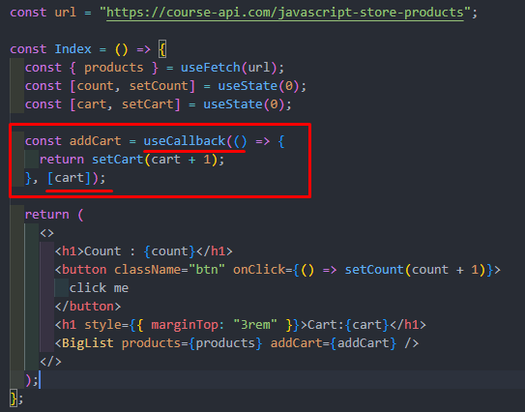

Ekhane render hobe tokhon e jokhon e cart value (dependency) change hobe.Otherwise render hobe na.

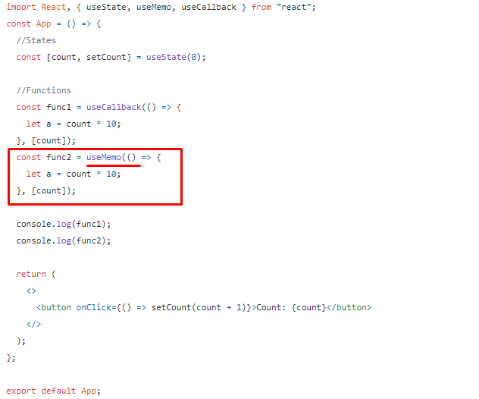

Ekhane useMemo() ,useCallback() er motoi kaj korbe but era shudhu value return korbe.

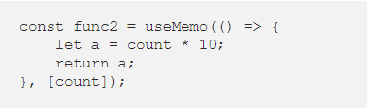

Ekhane 10 return korbe.

